Azure CLI

Users with workflows requiring files in their local environment will benefit from the [Azure CLI](https://learn.microsoft.com/en-us/cli/azure/). An Azure account is not required; however, you will need to obtain a [read-only SAS token](https://planetarycomputer.microsoft.com/docs/concepts/sas/).

# Example

* User needs to download data for local processing
* User accesses data via the Azure CLI, anonymously
* Total cost to end user: **Free**

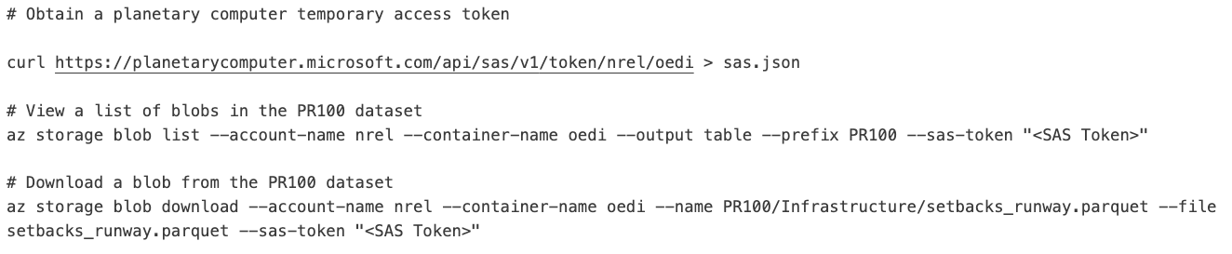

This code snippet shows how to obtain a temporary access token for the “oedi” container and use it to list available blobs and download a blob.

Azure Python Tools

The [planetary-computer](https://pypi.org/project/planetary-computer/) python package provides a high-level interface for accessing public data. An Azure account is not required. OEDI provides a Jupyter notebook example for each data set that has been migrated to Azure. Follow the Azure “View Data Lake” link in a data set’s catalogue entry to find its corresponding example notebook.

# Example

* User needs to load a subset of a large data set for local processing
* User modifies the data set’s Jupyter notebook example and anonymously loads the data they are interested in
* Total cost to end user: **Free**

[This notebook](https://nbviewer.org/github/microsoft/AIforEarthDataSets/blob/main/data/pv_rooftop.ipynb) demonstrates basic usage of the PV Rooftop data available on Azure.